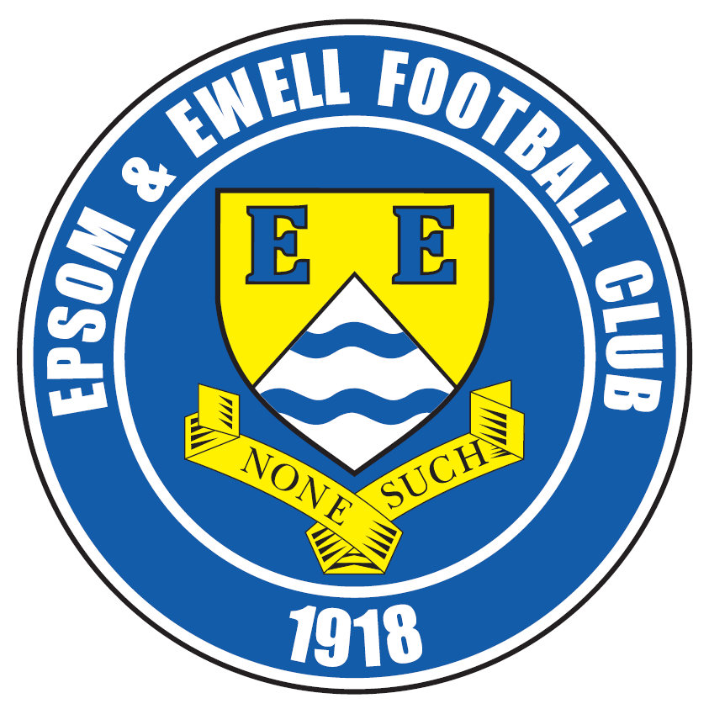 | Epsom & Ewell  17  v  Bagshot  Saturday, 19th January 2019 – 3.00 p.m.
Good afternoon and welcome to the players, supporters and officials of Bagshot who are making their second long visit of the season, this time for an important League match. We have two wins over them this year but both were tight matches, so will have to make sure we perform if we are to secure a much needed treble.

We were last on show here last Saturday when we hosted Ash United and it’s fair to say that it was two points dropped as we let a half time lead slip, having to settle for a 1-1 draw. Our opponents also drew 1-1 last weekend, but will have taken far greater confidence from that result against likely Champions Bedfont & Feltham, who defeated them heavily on the opening day of the season. ……..

Our next match is at Godalming Town on Saturday 26th January, and we return here a fortnight today for an extremely pivotal encounter with Farnham Town.

We also have many matches and players available for sponsorship, don’t be shy, just ask a Committee member for details.

Finally, just on a personal note, today is Nathan Lambert’s 100th Epsom & Ewell match and he appears to enjoy coming more than ever nowadays, although let’s be honest, last season was a testing time for most of us, let alone a ten year old! His first match was at the age of four months old where, scarily, he nearly got killed by a stray ball up at Merland Rise! Luckily he was too young to realise and it didn’t put him off!

I sometimes wonder whether he will still be watching us over the decades to come, as so many of our regulars have done for decades in the past. We so desperately need a ground of our own or else, sadly that will become an ambition that is denied to him and many of our other local people who may well have become supporters of the future had we got back home. We hope to have more news on this situation shortly.

Enjoy the game!

Rich

You can follow us on Facebook: www.facebook.com/epsomandewellfc
Twitter: @EEFCOfficial Instagram at: www.instagram.com/epsomandewellfc
and Youtube at: www.youtube.com/channel/UCtLrpS0x5OaYUACRT34_zng

Cover photo by Gemma Jarman

Taryn Smith puts us ahead in the away League meeting with Bagshot back in August 2018, which was won 3-0


Cherry Red Records Combined Counties League
Division One Table 2018/19
inc Saturday 12th January 2019 | P | W | D | L | F | A | Pts | GD | H | A

Frimley Green | 22 | 15 | 5 | 2 | 45 | 26 | 50 | +19 | 3-0 | 23/2
Bedfont & Feltham | 20 | 14 | 5 | 1 | 66 | 22 | 47 | +44 | 4-4 | 13/4
Sheerwater | 21 | 13 | 4 | 4 | 51 | 29 | 43 | +22 | 2-3 | ???
Epsom & Ewell | 22 | 13 | 3 | 6 | 51 | 35 | 42 | +16 | X | X
Farnham Town | 18 | 12 | 4 | 2 | 44 | 14 | 40 | +30 | 2/2 | 1-4
Tooting Bec | 21 | 11 | 5 | 5 | 46 | 28 | 38 | +18 | 3-1 | 30/3
Dorking Wanderers Res | 24 | 11 | 4 | 9 | 55 | 52 | 37 | +3 | 3-0 | 3-5
Ash United | 22 | 10 | 5 | 7 | 54 | 45 | 35 | +9 | 1-1 | 2-1
Sandhurst Town | 19 | 10 | 3 | 6 | 30 | 32 | 30 | -2 | 20/4 | 2-0
British Airways | 21 | 8 | 4 | 9 | 45 | 46 | 28 | -1 | 16/2 | 2-3
Chessington & Hook Utd | 20 | 8 | 4 | 8 | 38 | 40 | 28 | -2 | 1-2 | 4-1
Bagshot | 24 | 6 | 4 | 14 | 28 | 69 | 22 | -41 | 19/1 | 3-0
Godalming Town | 20 | 6 | 3 | 11 | 29 | 44 | 21 | -15 | 3-2 | 26/1
Eversley & California | 19 | 5 | 1 | 13 | 34 | 47 | 16 | -13 | 1-0 | 1-2
Kensington Borough | 20 | 3 | 4 | 13 | 26 | 55 | 13 | -29 | 1-1 | 9/3
FC Deportivo Galicia | 19 | 3 | 3 | 13 | 28 | 38 | 12 | -10 | 12/3 | 3-0
Fleet Spurs | 21 | 4 | 0 | 17 | 35 | 61 | 12 | -26 | 6/4 | 3-2
Cove | 19 | 3 | 1 | 15 | 22 | 44 | 10 | -22 | 3-2 | 2-1

AC London (removed) | 15 | 9 | 2 | 4 | 36 | 25 | 29 | +11 | - | 6-0

Lucky Day? – 19th January
Played 10 - Won 5 Drawn 1 Lost 4 - For 29 Against 26 - PPG 1.60 - Above Average
Our Club record against Bagshot
Played 2 - Won 2 Drawn 0 Lost 0 - For 4 Against 0 - PPG 3.00 - Perfect
Bagshot‘s last visit
25th September 2018 - Won 1-0 - Combined Counties League Cup Second Round

First Eleven Appearances 2018/19 - (max 31)
Name | Debut | 2018/19 |  |  |  | Career Totals
Name | Debut | App | Sub | Tot | Goals | App | Sub | Tot | Goals
BENNETT Bobby | 12/08/2018 | 25 | 0 | 25 | 17 | 25 | 0 | 25 | 17
BETANCOURT Steve* | 18/08/2018 | 21 | 1 | 22 | 1 | 21 | 1 | 22 | 1
BORRETT Ricky* | 04/08/2018 | 9 | 0 | 9 | 0 | 9 | 0 | 9 | 0
CAMPBELL Kieran* | 29/09/2012 | 7 | 3 | 10 | 2 | 59 | 3 | 62 | 2
CAMPBELL Theo* | 28/08/2018 | 2 | 9 | 11 | 1 | 2 | 9 | 11 | 1
CARNEY Billy | 12/01/2019 | 0 | 1 | 1 | 0 | 0 | 1 | 1 | 0
CAULCRICK Joshua | 17/02/2018 | 0 | 4 | 4 | 0 | 0 | 5 | 5 | 0
CHICK Ben | 29/12/2018 | 1 | 2 | 3 | 0 | 1 | 2 | 3 | 0
CHIN Louis | 08/12/2018 | 4 | 0 | 4 | 0 | 4 | 0 | 4 | 0
CONNELLY Lloyd | 14/10/2017 | 31 | 0 | 31 | 4 | 61 | 4 | 65 | 6
DOBRAJ Endrit* | 18/11/2017 | 5 | 2 | 7 | 1 | 24 | 6 | 30 | 1
DYSON Ben* | 12/08/2017 | 0 | 1 | 1 | 0 | 28 | 14 | 42 | 2
ELGAR Luke | 04/08/2018 | 9 | 3 | 12 | 1 | 9 | 3 | 12 | 1
ELGAR Scott* | 12/08/2018 | 4 | 9 | 13 | 0 | 4 | 9 | 13 | 0
GAFFNEY Luke * | 16/08/2014 | 2 | 2 | 4 | 0 | 12 | 3 | 15 | 0
GAYLE Roy | 06/11/2018 | 3 | 1 | 4 | 0 | 3 | 1 | 4 | 0
GILL George* | 28/08/2018 | 2 | 0 | 2 | 0 | 2 | 0 | 2 | 0
GRIFFIN Reisse | 08/08/2015 | 18 | 0 | 18 | 3 | 122 | 13 | 135 | 11
GRIFFITHS Hakim | 08/12/2018 | 1 | 1 | 2 | 1 | 1 | 1 | 2 | 1
HEAGNEY Adam | 16/08/2016 | 31 | 0 | 31 | 1 | 98 | 13 | 111 | 3
HENDRY Rob | 08/08/2015 | 15 | 0 | 15 | 11 | 99 | 23 | 122 | 39
JEANNOEL Germaine | 02/12/2017 | 1 | 10 | 11 | 2 | 3 | 17 | 20 | 3
JONES David* | 31/08/2018 | 6 | 2 | 8 | 0 | 6 | 2 | 8 | 0
LOFTUS-CHEEK Joe | 06/08/2017 | 0 | 1 | 1 | 0 | 14 | 8 | 22 | 6
MARTINEZ Olly | 29/09/2018 | 8 | 3 | 11 | 2 | 8 | 3 | 11 | 2
MCKAY Alex | 20/12/2008 | 1 | 0 | 1 | 0 | 163 | 39 | 202 | 13
MORGAN Sam | 11/09/2018 | 2 | 4 | 6 | 0 | 2 | 4 | 6 | 0
MURPHY Scott | 20/01/2007 | 26 | 0 | 26 | 3 | 73 | 2 | 75 | 7
MURPHY Todd | 27/11/2018 | 1 | 3 | 4 | 0 | 1 | 3 | 4 | 0
ROBERTS Liam | 12/08/2017 | 22 | 2 | 24 | 11 | 43 | 16 | 59 | 16
SMITH Taryn | 28/10/2017 | 6 | 6 | 12 | 5 | 14 | 10 | 24 | 5
SULLIVAN Ryan | 04/08/2018 | 19 | 1 | 20 | 0 | 19 | 1 | 20 | 0
SUTHERLAND Mitchel* | 04/08/2018 | 1 | 1 | 2 | 0 | 1 | 1 | 2 | 0
THOMPSON Elliott | 09/02/2016 | 20 | 3 | 23 | 1 | 30 | 12 | 42 | 2
WATTS Jamie | 03/11/2018 | 6 | 0 | 6 | 1 | 6 | 0 | 6 | 1
WHITE Sean* | 02/08/2014 | 9 | 4 | 13 | 4 | 29 | 25 | 54 | 9
WOODCOCK Josh* | 22/09/2018 | 1 | 0 | 1 | 0 | 1 | 0 | 1 | 0
WRIGHT Kieran* | 15/09/2018 | 3 | 3 | 6 | 0 | 3 | 3 | 6 | 0
YOUNG Conor | 07/03/2015 | 19 | 0 | 19 | 0 | 52 | 0 | 52 | 0
* - Player has left the club

Recent Results and Fixtures
Combined Counties League – Saturday 12th January 2019
Bagshot | 1-1 | Bedfont & Feltham
British Airways | 1-2 | Farnham Town
Cove | 3-2 | Fleet Spurs
Dorking Wanderers Reserves | 3-1 | Eversley & California
Epsom & Ewell | 1-1 | Ash United
Frimley Green | 3-0 | Sandhurst Town
Sheerwater | 5-1 | Godalming Town
Tooting Bec | 3-3 | Chessington & Hook United
Surrey Premier Cup Second Round – Tuesday 15th January 2019
Bagshot | 1-3 @ Frimley | Frimley Green
Combined Counties League Cup Third Round – Tuesday 15th January 2019
AFC Hayes | 0-1 | Bedfont & Feltham
Chertsey Town | 1-2 | Abbey Rangers
Knaphill | 3-1 | Fleet Spurs
Sheerwater | 0-3 | Banstead Athletic
Spelthorne Sports | 0-1 | Hanworth Villa
Combined Counties League Cup Third Round – Wednesday 16th January 2019
FC Deportivo Galicia | V | Sutton Common Rovers
Guildford City | V | CB Hounslow United
Combined Counties League – Saturday 19th January 2019
Bedfont & Feltham | V | Fleet Spurs
Chessington & Hook United | V | Kensington Borough
Epsom & Ewell | V | Bagshot
Eversley & California | V | Cove
Farnham Town | V | Dorking Wanderers Reserves
FC Deportivo Galicia | V | Sandhurst Town
Sheerwater | V | Frimley Green
Combined Counties Division One League Cup QF – Tuesday 22nd January 2019
Tooting Bec | V | Frimley Green
Combined Counties League – Tuesday 22nd January 2019
Farnham Town | V | Cove
Combined Counties Division One League Cup QF – Wednesday 23rd January 2019
FC Deportivo Galicia | V | Godalming Town
Combined Counties Division One League Cup QF – Saturday 26th January 2019
Fleet Spurs | V | Chessington & Hook United
Combined Counties League – Saturday 26th January 2019
Ash United | V | Tooting Bec
Recent Results and Fixtures
Combined Counties League – Saturday 26th January 2019
Bagshot | V | Farnham Town
British Airways | V | Eversley & California
Cove | V | Sheerwater
Dorking Wanderers Reserves | V | Frimley Green
Godalming Town | V | Epsom & Ewell
Kensington Borough | V | FC Deportivo Galicia
Sandhurst Town | V | Bedfont & Feltham
Combined Counties League – Tuesday 29th January 2019
Sheerwater | V | British Airways
Combined Counties League – Saturday 2nd February 2019
Chessington & Hook United | V | Cove
Epsom & Ewell | V | Farnham Town
Eversley & California | V | Bagshot
FC Deportivo Galicia | V | Godalming Town
Fleet Spurs | V | Tooting Bec
Sandhurst Town | V | British Airways
Sheerwater | V | Ash United

Bagshot F.C. – History
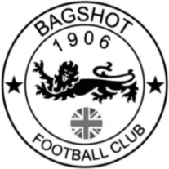
The football club was established in 1906, and for many of the early years the team played in the local Ascot and Woking district leagues. In that period the club played matches at Pennyhill Park and Connaught Park in the village.

In the late 1970s the club were permanently based at the Pennyhill Park ground, College Ride and in 1982 the club were promoted to the Surrey Intermediate League, and each year won successive promotions.

The club won the Senior Division championship in 1986/87 and were then promoted to the Surrey Premier League (later to become the Surrey Elite League). The club were also Surrey County cup semi-finalists in both 1985 and 1986.

After more successful seasons in the Surrey Intermediate League the club then moved to the Berks and Bucks league, with the highlight winning the Maidenhead Norfolkian cup in 2007 before leaving for the Aldershot & District League.

After winning Division Two in 2005/06 they were promoted to Division One, which they won in 2008/09, earning promotion to the Senior Division.

They subsequently won the Senior Division and the Surrey Intermediate Cup in 2011/12, before going on to win both the Senior Division and Senior Division Cup double in both 2012/13 and 2013/14, along with the Aldershot Cup.

After winning the Senior Division again in 2015/16, they were promoted to Division One of the Combined Counties League for the first time in the club history.

This is all due to the hard work and time that the Wickens family have put into the club over the last 40 years.

From behind the goal
Epsom & Ewell 1-1 Ash United
Combined Counties League - Division One - Saturday 12th January 2019

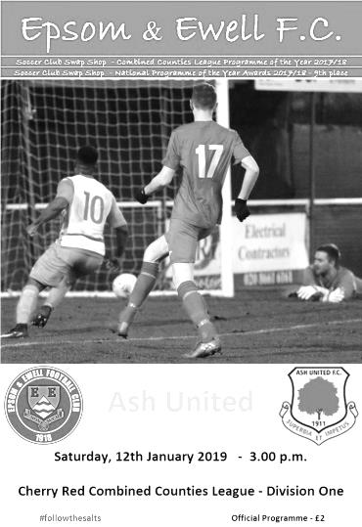
Self-inflicted damage as Ash snatch a point

In recent weeks we have missed a number of chances and finally this time it came back to hurt us as Ash United left High Road with a point from a 1-1 draw that left us right on the outskirts of the promotion places and with absolutely no margin for error remaining.

We made only one change from our win at Cove with Ben Chick coming in for the absent Ryan Sullivan but also appeared to have a much stronger bench available including Hakim Griffiths and new boy dual registered with Chipstead, Billy Carney. Both would enter the fray later on.

We started well and almost opened up our account after 25 seconds as Liam Roberts sent over a low cross from the right wing which Chick met beyond the far post with a powerful shot, but it was from a difficult angle and went over the bar. We then had a couple of free kicks but Adam Heagney's deliveries failed to cause Jamie Cunningham in the Ash goal any concern. This would set the pattern for the opening half as we did most of the pressing and would win a few free kicks in dangerous positions but failed to hurt the opposition in each case. Rob Hendry sent one free kick under the jumping wall but the shot lacked power and Cunningham made the save.

In the 17th minute Bobby Bennett latched on to a deep ball over the defence and hit his shot as powerfully as he could from just eight yards out but Cunningham made a great save before Chick then sent a header over the bar from a Hendry free kick. Chick remained prominent and was just wide with a shot on the turn while Roberts saw his shot blocked after he had been put through with a clever pass.

The goal surely had to come and in the 40th minute Hendry broke through the defence and drilled his shot across Cunningham low into the far corner of the net from 15 yards. Incredibly, and for the third time in four matches at High Road the ball came back out of the goal off the supporting stanchion and it looked as though the Assistant wasn't going to award it, but fortunately Bennett was first to react to side foot the loose ball back into the net just in case there had been any doubt!

Bennett then nearly made it 2-0 but dragged a shot just wide of the far post before the visitors had a free kick that appeared to deflect against a hand on its way through to Conor Young but it was clearly inadvertent and the teams went off at the half with our boys in a strong position.

I really thought that if we could get an early second goal in the second half we would have a comfortable afternoon, but we came out showing caution. Young was dallying on the ball in

his own area to waste a second or two, but it was far too early to do this and it sent the message out that we were prepared to sit on the lead. The visitors grew in confidence and a deep right wing ball would have been met at the far post had Louis Chin not been there to head the ball away from danger at the last minute. Simon Funnell made changes with Griffiths and Carney coming on for Chick and Roberts respectively but in the 69th minute Lloyd Connelly attempted an unnecessary header back which was reached by the Ash striker just ahead of Young who brought him down, earning a harsh yellow card for his challenge, although it looked like a foul from where I was. Neil Hardy slotted the penalty away a minute later and we were level.

This was extremely frustrating. We had been substantially the better side but there had been real urgency missing from our play. That returned for the last twenty minutes as the players realised that time was running out. Carney's first effort on goal was palmed away by Cunningham but in the 77th minute Griffiths got through on goal, being brought down on the edge of the box by the Ash Captain Bradley Passfield. Griffiths actually managed to bounce back up from the challenge and then find Carney who had a tap in from just twelve yards out but the referee had already blown the whistle.

Almost every week I bemoan the fact that the advantage law is there to help the official, who only has to hold on for a moment or two to see whether a team can play on. Regrettably this official could not wait to blow the whistle almost immediately in each case, denying him the opportunity to play the advantage and hurting us badly in this case. The free kick was wasted and the chance was gone and Passfield had achieved his objective, even if the red card ensured he would play no further part in this match.

Hendry had one more chance when he received a deep ball at the far post with five minutes of normal time remaining, but his first touch took him wider than he would have liked and he fired his shot from eight yards into the side netting. Frustrations were getting the better of our players and Scott Murphy and Elliott Thompson both picked up yellow cards for questioning the referees decisions; Thompson in particular was extremely justified in his protests after another promising move was broken up for an offside flag in the middle of the field when the ball was reached by Hendry on the far side but of course we never had the chance for play to develop because the whistle blew as soon as the flag had been spotted. This was arguably the fault of the Assistant, and again some of them seem to wait until the player has the ball while others put the flag up straight away. Frustrating!

Now these officiating decisions did hurt us and we probably would have gone on to win had they fallen in our favour, but if we had pushed on and been more clinical ourselves then we'd have been a few goals ahead by the time of the incidents and no one would have been talking about them. As a result we have to look to our own failings for not claiming the points against one of the weaker teams we have faced this season. Massive matches now follow against Bagshot, Godalming and Farnham Town and it is probably fair to say that we will now have to win our remaining twelve matches to stand a chance and even that may not be enough. However, that is our target now and we have to deal with it.

Epsom and Ewell: Conor Young, Louis Chin, Reisse Griffin, Elliott Thompson,
Adam Heagney, Lloyd Connelly, Liam Roberts, Scott Murphy (c), Rob Hendry, Bobby Bennett, Ben Chick

Subs: Hakim Griffiths for Chick (59), Billy Carney for Roberts (68)

This Day in History - 19th January
Date | Day | Competition |  | Opponents |  | Scorers
19/01/29 | Sat | London League | H | Beckenham | 7-3 | G.Carmichael, R.Marlow (4), T.Hill, F.Behn
19/01/35 | Sat | London League | A | Leavesden | 2-6 | W.Rich, H.Pullen
19/01/46 | Sat | Friendly | H | R.E.M.E. Putney | 9-2 | G.Brogdale (5), F.Adey (2), S.Tingey, o.g.
19/01/52 | Sat | Corinthian League | A | Eastbourne | 0-6
19/01/57 | Sat | Friendly | H | Woodford Town | 5-2 | B.Jenkins (4, 2 pens), B.Hayes
19/01/74 | Sat | Surrey Senior League Charity Cup 2 replay | H | Westfield | 2-1 | T.Tuite, M.Talmage
19/01/80 | Sat | London Senior Cup 1 | A | Woking | 1-2 | T.Tuite
19/01/88 | Tue | Isthmian League 2s | H | Yeading | 0-0
19/01/91 | Sat | Isthmian League 2s | A | Maidenhead United | 0-4
19/01/02 | Sat | Isthmian League 3 | A | Witham Town | 3-0 | J.Buckley, J.Rogers, A.Toppin
Historical Decades
90 years ago – Epsom Town F.C.
19/01/29 | Sat | London League | H | Beckenham | 7-3 | G.Carmichael, R.Marlow (4), T.Hill, F.Behn
80 years ago – Epsom F.C.
21/01/39 | Sat | London League | A | Finchley | 0-2
70 years ago – Epsom F.C.
22/01/49 | Sat | London League | A | Leavesden | 2-1 | N.Griffiths, K.Minter
60 years ago – Epsom F.C.
24/01/59 | Sat | Corinthian League | H | Worthing | 6-2 | R.Carter (4), B.Willis, T.Millard
50 years ago – Epsom & Ewell F.C.
25/01/69 | Sat | Athenian League 2 | H | Marlow | 0-0
40 years ago – Epsom & Ewell F.C.
20/01/79 | Sat | Isthmian League 1 | A | Harwich & Parkeston | 1-5 | T.Tuite (pen)
30 years ago – Epsom & Ewell F.C.
21/01/89 | Sat | F.A. Vase 4 | H | Hailsham Town | 1-2 | R.Strong (pen)
20 years ago – Epsom & Ewell F.C.
23/01/99 | Sat | Isthmian League 3 | H | Cheshunt | 0-0
10 years ago – Epsom & Ewell F.C.
20/01/09 | Tue | Surrey Senior Cup 3 | H | Redhill | 3-0 | J.Keys, K.Hough (2)

History Corner – 19th January
90 years ago today we hosted Beckenham to West Street for a London League match but weren’t that generous in our welcome as we defeated them 7-3. Reg Marlow was only 27 and in his prime, even though he had already scored the majority of his goals for us by then. However, he scored another four this day while George Carmichael, Freddie Behn and Ted Hill got the others. This Beckenham club would survive until 1969, being replaced in 1971 by the one we met this season in the F.A. Cup.

70 years ago today the Royal Mechanical Engineers (Putney) visited West Street for a friendly, but were humbled 9-2. They were one of many teams from the Armed Forces that sprung up during World War Two but were not of a very high standard. Gordon Brogdale was in the process of scoring 44 goals in 32 matches that season and he got five this day, while Frank Adey scored twice and Syd Tingey and an own goal rounded off the scoring.

62 years ago today it was Brian Jenkins’ turn to score four goals against Woodford Town in a friendly that was won 5-2 at West Street. Brian Hayes scored the other goal.

60 years ago this week we were at home to Worthing in a Corinthian League match. We had beaten them 10-0 a few years previously and on this occasion we won 6-2 with Reg Carter scoring four times. It is worth noting as I report on these many high scorers that we have had just one player score four goals in a match for us in the last twenty years! Bernard ‘Podge’ Willis and Tommy Millard scored the other goals.

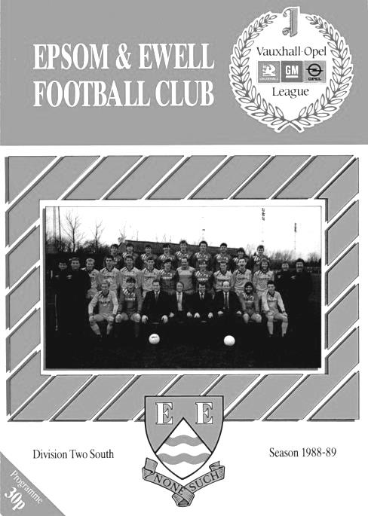
45 years ago today we witnessed the passing of the baton in the Surrey Senior League as we defeated Westfield in a Charity Cup replay. Westfield were the team to beat back then, while we were spending our first season back at that level. Although we wouldn’t beat them to the League title that season, our time was coming and in the four meetings that season, we won two and drew two.

30 years ago this week our first F.A. Vase run for eleven years ended at the hands of Hailsham Town. We had negotiated five matches previously, four of which required extra time and one needing a replay so it was maybe poetic justice that we departed the competition in extra time also, but we were three minutes away from going through to the last sixteen thanks to Richard Strong’s penalty before the late equaliser, and a penalty to the visitors sealed our fate. (see programme pictured)

20 years ago this week we had “penaltygate”! We hosted Cheshunt in an important League match and were awarded a penalty midway through the second half. We scored it, but the referee decided there had been encroachment by one of our players. Ok, most supporters thought, we’ll have to retake it, but the referee Ralph Bone thought otherwise and awarded them an indirect free kick on the penalty spot! A more bizarre decision I have yet to witness at an Epsom match and ironically Cheshunt, who held on for a goalless draw that day, went up by a point while Mr Bone made it onto the League list. You couldn’t make it up!

Centre page for results

Centre page for results



EL Records Premier Challenge Cup
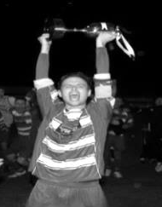
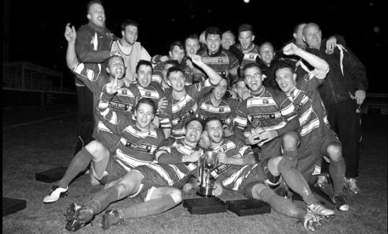
First Round
Camberley Town | 1-3 | Cobham
Horley Town | 0-1 | Chertsey Town
Badshot Lea | 3-1 | Walton & Hersham
FC Deportivo Galicia | 4-1 | Cove
Chessington & Hook United | 2-4 | AFC Hayes
Farnham Town | 1-2 | Southall
Hanworth Villa | 3-1 | Kensington Borough
Second Round
Bedfont & Feltham | 2-0 | Tooting Bec
Sheerwater | 1-0 | Balham
Ash United | 2-3 | Fleet Spurs
Frimley Green | 0-2 | Guildford City
Godalming Town | 2-0 | Dorking Wanderers Reserves
Abbey Rangers | 3-0 | Redhill
FC Deportivo Galicia | 5-0 | AC London
Cobham | 0-3 | AFC Hayes
Abandoned after 88 minutes due to serious player injury - Match awarded to AFC Hayes
CB Hounslow United | 4-1 | Badshot Lea
Hanworth Villa | 2-1 | Sandhurst Town
Epsom & Ewell | 1-0 | Bagshot
Sutton Common Rovers | 4-2 | Southall
Chertsey Town | 3-2 | British Airways
Eversley & California | 1-5 | Knaphill
Banstead Athletic | 4-3 | Colliers Wood United
Spelthorne Sports | 2-1 | Raynes Park Vale
Third Round
FC Deportivo Galicia | 16/1 | Sutton Common Rovers
AFC Hayes | 0-1 | Bedfont & Feltham
Epsom & Ewell | 12/2 | Godalming Town
Sheerwater | 0-3 | Banstead Athletic
Guildford City | 16/1 | CB Hounslow United
Spelthorne Sports | 0-1 | Hanworth Villa
Knaphill | 3-1 | Fleet Spurs
Chertsey Town | 1-2 | Abbey Rangers

Previous Managers

In our latest instalment we are finally able to report on happier times!

Pat O’Connell - July 1973 – 27th February 1982

The times were about to change. Well over a decade of under achievements (not necessarily all down to the Managers it should be pointed out) had left the club in a position where it nearly folded. At a public meeting Crystal Palace Chairman Ray Bloye wiped out the club’s debt of £250 and brought in some new people for the Committee.

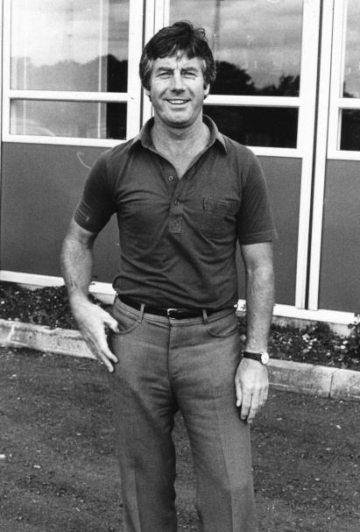
One of the first things that happened was that Bloye’s Assistant Dick Varey approached the Wimbledon Reserve Manager at the time, Pat O’Connell. He came over, bringing a number of players with him, not to mention an able Secretary in Stan Bailey.

Pat, whose real name was Brian, but picked up the nickname because of his surname, was born in Kensington on 13th September 1937 and became a professional footballer with his home town club, Fulham at the age of 14 when leaving school.

He played for Fulham for many seasons until 1965 before leaving for Crystal Palace and then Vancouver Royals in Canada after being asked to go by his friend and team mate Bobby Robson. Robson didn’t stay long in charge there but his replacement was a hero of O’Connell’s by the name of Ferenc Puskas! After some time there he returned to England and played in the Southern League for Brentwood, Dover and then finally Wimbledon from where he graduated from playing into Management, taking his Coaching badges under the watchful eyes of Dave Sexton and Ron Greenwood..

Our President Stella Lamont wrote an article many years back in a programme which described Pat as follows: “Pat devoted ten years to our club and was a family man. He married Ann, who sometimes helped at the club, and they had a son Sean and a daughter Sarah. He was not just interested in the football but was a true clubman who was concerned with the welfare of players, staff and supporters alike. And he was a true friend. When Pat decided to move on, for me it was the saddest day in football. He was quite simply the best Manager the club has ever had.”

Despite the success that was to follow, Pat’s first match in charge came on 1st September 1973 in a Surrey Senior League match to BAC Weybridge, who defeated us 2-1, despite a debut goal that day from a young striker who had also joined from Wimbledon Reserves, Tommy Tuite. The team started to get into its stride with O’Connell making his debut in a F.A. Cup defeat at home to Wimbledon of all clubs on 15th September!

The team to beat this season was Westfield who had won the League and Charity Cup double in 1973 and would again win the League in 1974 but we met them four times, winning two and drawing two, knocking them out of the Charity Cup in the process and wining the League Cup at Walton & Hersham’s old Stompond Lane ground with a 2-1 extra time victory over Malden Town; the club’s first trophy for 14 years.

Pat aimed higher in 1974/75 strengthening the team still further. Two players in particular came in that season by the names og Phil Walker and Trevor Lee from Cobham, having fallen out of the

League system as schoolboys. Added to the Captain Trevor Wales, and strong players like Willie Bennett and Alan Webb he also brought in Dave Worby from Walton & Hersham where he is still the record appearance holder, and Johnny Eales, a local lad that was returning to the club for his fourth spell.

The effects were dramatic opening up the season with a 5-0 win over Lion Sports and a 6-0 away win at Chessington United. Defeat came in the F.A. Cup at Redhill but with exception of a 2-0 home defeat to Virginia Water, our boys would not lose any other league matches, retaining the League Cup with a victory over that same club and narrowly losing the Charity Cup.

Of course the 1974/75 season cannot be referred to without a large mention of our performance in the F.A. Vase where we defeated several Athenian League clubs on our way to a narrow 2-1 defeat to Hoddesdon Town in the inaugural Final at Wembley Stadium on 19th April 1975. It is interesting to note that he beat his boyhood club Fulham to a Wembley appearance by just two weeks, although they would also finish as the losing side to West Ham United that day.

Pat had played in that Final as his career wound down but he would become more of a Manager than a Player/Manager from that point. Success continued though, despite the loss of Walker and Lee to Millwall. We returned to the Athenian League after a two year absence and instantly gained promotion as runners-up to Epping Town.

Then in 1976/77 we reached the Athenian League Cup Final, losing 1-0 to Chalfont St Peter. It would be our only appearance there as Pat’s ten year plan to reach the Isthmian League Premier Division was taking shape. We switched on the floodlights against Met Police in August 1977 as members of the newly formed Division Two and would go on to win the title with the constabulary side as runners-up. In 1978/79 we stabilised at the new level and the following season we won the Southern Combination Cup with an astonishing 7-2 win over Hampton. At Hampton!

For 1980/81 though, O’Connell realised that we needed to improve still further. The recently formed Youth side was beginning to bear fruit and new players like Peter Gaydon and Ian Finch joined us from Carshalton Athletic and they were important members of the team that would win the Surrey Senior Cup for the first and so far only time in our history, defeating Woking 2-1 at Sandy Lane, home of Tooting & Mitcham United.

On the way there we defeated Sutton United after a replay which was no mean feat as they reached the F.A. Trophy Final themselves that year, losing to Bishops Stortford. Stortford were in our Division and would win the title with three time F.A. Vase winners Billericay Town also going up. Despite our performance against those two clubs, which resulted in four draws, it was dropped points against other clubs that left us in third place, missing out on promotion by one spot. (It’s worth noting that when we did go up in 1984 we had fewer points than we got in 1980/81!)

The 1981/82 would be my first season as a supporter but it would also prove to be Pat’s last as Manager. We topped the table briefly and had a fantastic run to the last 32 of the F.A. Trophy, narrowly losing to Altrincham at West Street but finances were worse than realised and O’Connell was told that the money would have to be cut. The players weren’t happy and so, following a 1-0 defeat at Wembley on 27th February 1982 he decided to quit with most of the players, including Finch, Gaydon and Tuite, leaving the club, although Tuite would return in 1984.

When I met Pat in 2007 doing research for the club History Book Two Legs Not Four I found a fairly contented man, who still lives in retirement now, up on Box Hill. He had just gone back to being a cab driver in 1982 and was happy with his lot. He was still aggrieved at his treatment by our club, but looking back now, it was clear finances were stretched, maybe even to satisfy O’Connell’s dream and maybe the plug did need to be pulled. We would reach the Isthmian League Premier Division, but not on Pat’s watch. That was an achievement that would fall to his successor!

Player Sponsorship
Here is the latest list for 2018/19, with new photos showing all of our players and Management that are available for sponsorship.

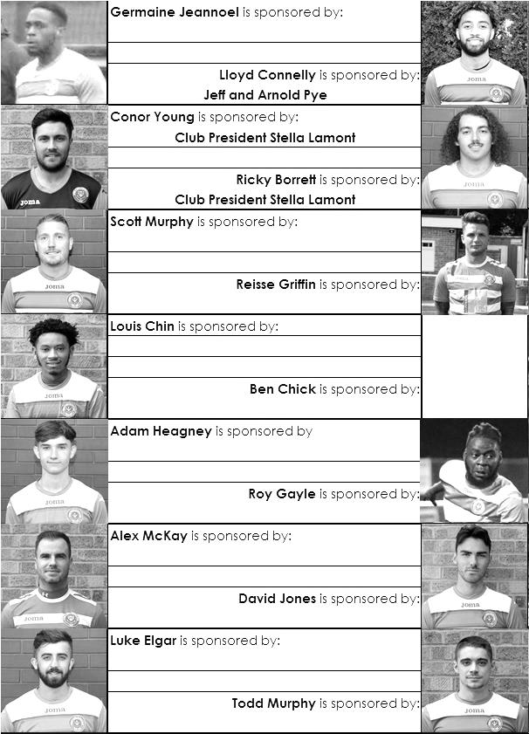

Sponsorship costs just £40 and it is easy to do. Just select a player who has not been previously sponsored and let a Committee Member know that you would like to sponsor them. Beware though. Until we have received the money it is possible for someone to jump in front of you, so don’t delay, sponsor today!
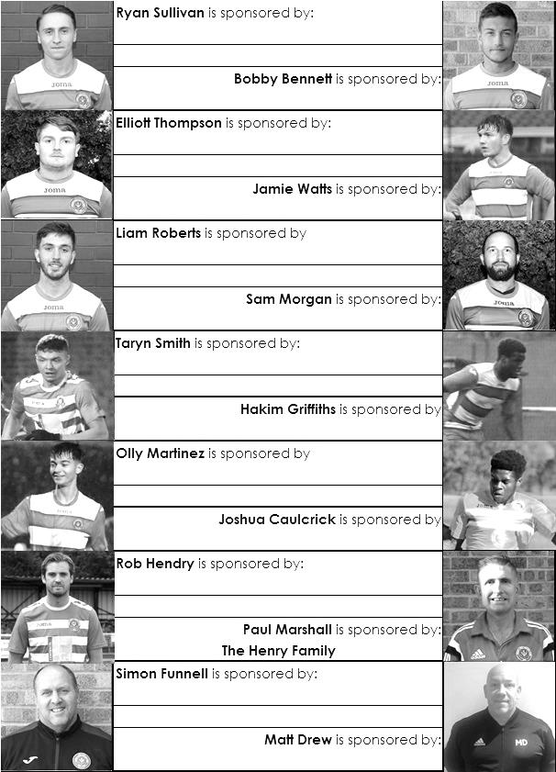

Match and Ball Sponsorships – 2018/19
Opponent | Date | Match Sponsor | Ball Sponsor
Chessington & Hook Utd | 21/08/18 | Club President - Stella Lamont
Beckenham Town (FAC) | 28/08/18 | Building Shop Ltd
Cove | 08/09/18 | EEFC Management Committee
Tooting Bec | 15/09/18 | Building Shop Ltd
Bagshot (LC) | 25/09/18
Sheerwater | 06/10/18 | Paul Merritt
Knaphill U23  (Surrey Premier Cup) | 23/10/18 | Jack Jarman
Frimley Green | 03/11/18 | Our Chairman’s Grandchildren – George, Joseph, Ezara and Inaya
Sandhurst Town (LD1C) | 06/11/18 | Richard Lambert
Kensington Borough | 17/11/18 | Jeff & Arnold Pye
Dorkinian (SPC) | 20/11/18
Dorking Wanderers Res | 27/11/18
Godalming Town | 01/12/18 | John Bonner
Bedfont & Feltham | 08/12/18
Eversley & California | 29/12/18
Ash United | 12/01/19 | Gary and Gemma Jarman
Bagshot | 19/01/19
Farnham Town | 02/02/19
Godalming Town (LC) | 12/02/19
British Airways | 16/02/19
AC London | 02/03/19
FC Deportivo Galicia | 12/03/19
Fleet Spurs | 06/04/19
Sandhurst Town | 20/04/19 | Club President - Stella Lamont
Match sponsorship costs just £60.00!

Sponsorship includes:

Admission, programmes and hospitality for three people.

A full page advert in the programme and mascot for the day (if required).

If you are interested, just speak to a Committee Member,
or drop me an email at: richard.c.lambert@gmail.com

Combined Counties League Premier Division
Opponents All-time Records
incl Saturday  12th January | P | W | D | L | F | A | PPG | GD | Best  Win | Worst  Loss
AC London | 1 | 1 | 0 | 0 | 6 | 0 | 3.00 | +6 | 6-0 | -
Bagshot | 2 | 2 | 0 | 0 | 4 | 0 | 3.00 | +4 | 3-0 | -
FC Deportivo Galicia | 1 | 1 | 0 | 0 | 3 | 0 | 3.00 | +3 | 3-0 | -
Tooting Bec | 1 | 1 | 0 | 0 | 3 | 1 | 3.00 | +2 | 3-1 | -
Fleet Spurs | 1 | 1 | 0 | 0 | 3 | 2 | 3.00 | +1 | 3-2 | -
Frimley Green | 11 | 9 | 1 | 1 | 35 | 5 | 2.55 | +30 | 7-1 | 0-1
Bedfont & Feltham | 3 | 2 | 1 | 0 | 17 | 7 | 2.33 | +10 | 9-2 | -
Godalming Town | 4 | 3 | 0 | 1 | 7 | 7 | 2.25 | 0 | 3-2 | 0-3
Ash United | 21 | 11 | 4 | 6 | 50 | 32 | 1.76 | +18 | 6-0 | 0-3
Farnham Town | 18 | 9 | 4 | 5 | 31 | 29 | 1.72 | +2 | 3-0 | 1-4
Cove | 36 | 17 | 9 | 10 | 80 | 58 | 1.67 | +22 | 7-0 | 1-6
Chessington & Hook | 30 | 13 | 9 | 8 | 63 | 45 | 1.60 | +18 | 6-0 | 1-3
Sheerwater | 5 | 2 | 2 | 1 | 10 | 5 | 1.60 | +5 | 3-0 | 2-3
Dorking Wanderers Res | 2 | 1 | 0 | 1 | 6 | 5 | 1.50 | +1 | 3-0 | 3-5
Eversley & California | 2 | 1 | 0 | 1 | 2 | 2 | 1.50 | 0 | 1-0 | 1-2
Sandhurst Town | 16 | 7 | 0 | 9 | 28 | 28 | 1.31 | 0 | 4-0 | 1-3
Kensington Borough | 1 | 0 | 1 | 0 | 1 | 1 | 1.00 | 0 | - | -
British Airways | 1 | 0 | 0 | 1 | 2 | 3 | 0.00 | -1 | - | 2-3

Combined Counties League – Division One
Saturday, 19th January 2019 - Kick-off 3.00 p.m.
Epsom and Ewell  (Royal Blue & White hoops) | V |  | Bagshot  (Yellow / Black / Black )
Squad | NUMBERS |  | Squad
Conor Young |  |  | Adrian Giles
Louis Chin |  |  | Ben Roberts
Luke Elgar |  |  | Jordan Baker
Reisse Griffin |  |  | Ben Blackwell
Lloyd Connelly |  |  | Ed Cardona
Jamie Watts |  |  | Michael Chapman
Adam Heagney |  |  | Matt Cox
Todd Murphy |  |  | Tom Cowen
Ryan Sullivan |  |  | Callum Eaton
Liam Roberts |  |  | Kurt Greenaway
© Scott Murphy |  |  | Lee Hathaway
Elliott Thompson |  |  | Sam Hermon
Bobby Bennett |  |  | Jamie Hills
Rob Hendry |  |  | Alex Jeffers
Roy Gayle |  |  | Scott Lyons
Olly Martinez |  |  | Mark Nicell
Germaine Jeannoel |  |  | Josh Ogunseye
Hakim Griffiths |  |  | Lekan Osideko
Joshua Caulcrick |  |  | Kai Parton – Edey
Taryn Smith |  |  | Jordan Ranger
Ben Chick |  |  | Kieron Sengelow
 |  |  | Dexter Skipp
 |  |  | Zac Spencer
Simon Funnell | MANAGER |  | Phil Ruggles
Matt Drew | ASST MANAGER
Sam Morgan | COACHES |  | Tony Roberts
Chantelle Farrell | PHYSIO
REFEREE: W.Douglas
ASSISTANTS: D.Merrick, D.McShane

OUR NEXT VISITORS TO HIGH ROAD
Farnham Town
Combined Counties League – Division One
Saturday, 2nd February 2019 – 3.00 pm

